**1. Constant Folding**

* **Concept:** Evaluate expressions involving only constants at compile time.
* **Example:**
  + - **Before Optimization (Intermediate Code):**

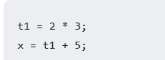

* **After Constant Folding:**

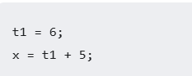

* **Further after Optimization:**



**2. Constant Propagation**

* **Concept:** If a variable is assigned a constant value, replace subsequent uses of the variable with that constant value until the variable's value is changed again.
* **Example:**
* **Before Optimization:**

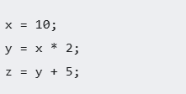

* **After Constant Propagation:**

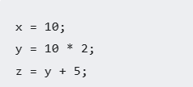

* **Further after Constant Propagation:**

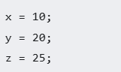

**3. Dead Code Elimination**

* **Concept:** Remove code whose result is not used or has no side effects.
* **Example:**
* **Before Optimization:**

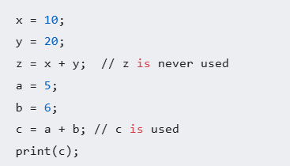

* **After Dead Code Elimination:**

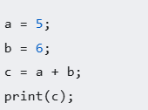

**4. Algebraic Simplification**

* **Concept:** Apply algebraic identities to simplify expressions.
* **Example:**
  + **Before Optimization:**

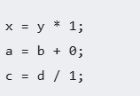

* **After Algebraic Simplification:**

